Sure. In Python, there are 5 main keywords used in exception handling:
- try
- except
- else
- finally
- raise
There is also as, which is commonly used with except, but it is not specifically an exception-handling keyword.

1. try

Meaning
try is used to identify a block of code where an exception might occur.

Use
It tells Python:
"Execute this operation, and if an exception happens, look for an appropriate handler."

Important point
- try itself does not handle the exception.
- It only defines the code that needs to be monitored.
- A try block must be followed by at least one except or a finally.

2. except

Meaning
except is used to catch and handle an exception raised inside the try block.

Use
It tells Python:
"If this particular type of exception occurs, execute the appropriate handling logic."

Important point
You should generally catch specific exceptions rather than catching every possible exception.
For example, conceptually:
- ValueError → handle invalid values
- TypeError → handle incorrect types
- KeyError → handle missing dictionary keys
You can have multiple except blocks for different exception types.

3. else

Meaning
else executes when the try block completes without raising an exception.

Use
It is useful for separating:
- Code that might fail → try
- Code that should execute only after successful execution → else

Important point
Think of it as:
"try succeeded, so now perform the next operation."
The else block does not execute if an exception occurs in the try block.

4. finally

Meaning
finally contains code that should execute regardless of whether an exception occurs.

Use
It is mainly used for cleanup operations.
Typical use cases include:
- Closing files
- Closing database connections
- Releasing resources
- Cleaning temporary resources
- Disconnecting from external services

Important point
finally normally executes in both situations:
Exception occurs → finally runs
No exception → finally runs
That's why it's called finally—it is the final cleanup stage.

5. raise

Meaning
raise is used to manually raise an exception.

Use
You use it when your program detects an invalid or unexpected situation and you want Python to treat it as an exception.
Common use cases:
- Input validation
- Business-rule validation
- Custom exceptions
- Propagating an existing exception
- Enforcing conditions in your application
For example, conceptually:
"The age is negative, so this is invalid. Raise an appropriate exception."

Important point
raise is different from except.
raise → generates/propagates an exception
except → catches/handles an exception

6. as

Is as an exception-handling keyword?
Technically, as is a Python keyword, but it isn't specifically an exception-handling keyword.
It is commonly used with except to give the exception object a name.

Use
It allows you to access information about the exception, such as:
- Error message
- Exception details
- Exception object itself
- Logging information
Think of it as:
"Catch this exception and give me access to the exception object."

7. How They Work Together
The overall flow is:
try
│
Did exception occur?
/ \
No Yes
│ │
else except
│ │
└───────┬───────┘
│
finally
And raise can be used independently whenever you need to generate or propagate an exception.

Hierarchy of Exception handling
____________________________________________________________________________
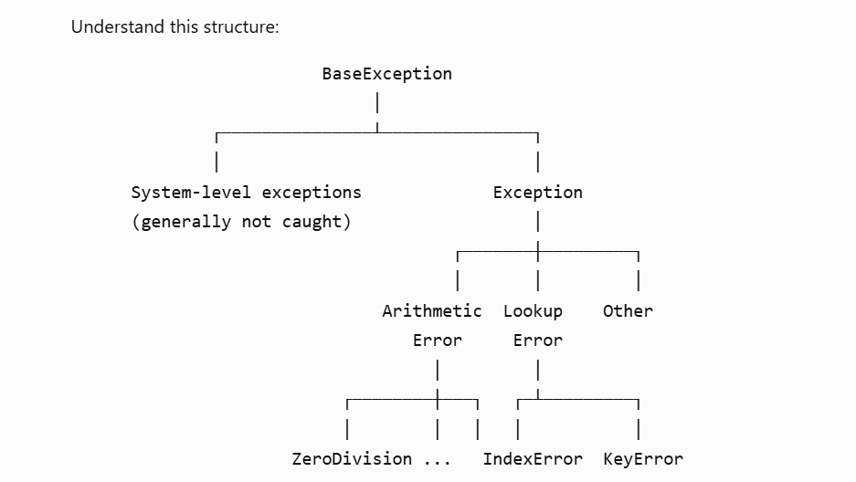

Examples of exception handling
______________________________________________________________________________

1. ValueError
ValueError occurs when the type is correct but the value is inappropriate.

Example
age = int("abc")
Here, int() expects a string containing a valid number, but "abc" cannot be converted to an integer.
try:
age = int("abc")
except ValueError:
print("Invalid value. Please provide a number.")
Output:
Invalid value. Please provide a number.

Real-world example
def calculate_age(age):
if age < 0:
raise ValueError("Age cannot be negative")

return age

try:
age = calculate_age(-10)
except ValueError as error:
print(error)
Output:
Age cannot be negative

2. TypeError
TypeError occurs when you perform an operation with an inappropriate data type.

Example
try:
result = "10" + 20
except TypeError:
print("Cannot add string and integer")
Output:
Cannot add string and integer
Why?
"10" → string
20 → integer
Python doesn't know how to perform "10" + 20.

Another example
try:
result = len(100)
except TypeError as error:
print(error)
Output will be similar to:
object of type 'int' has no len()

3. AttributeError
AttributeError occurs when you try to access an attribute or method that the object doesn't have.

Example
name = "John"

try:
name.append("Smith")
except AttributeError:
print("String does not have an append method")
Output:
String does not have an append method
Why?
A list has:
names = ["John"]
names.append("Smith")
But a string doesn't have append().

Another example
class User:
def __init__(self, name):
self.name = name

user = User("John")

try:
print(user.age)
except AttributeError:
print("User does not have an age attribute")
Output:
User does not have an age attribute

4. NameError
NameError occurs when you try to access a variable or name that hasn't been defined.

Example
try:
print(username)
except NameError:
print("username is not defined")
Output:
username is not defined
Because we never did:
username = "John"

Another example
try:
result = calculate_salary()
except NameError:
print("calculate_salary function does not exist")
This is common when you accidentally:
- Misspell a variable
- Misspell a function
- Use a variable before defining it
For example:
user_name = "John"

print(username)
Here user_name and username are different names.

5. ArithmeticError
ArithmeticError is a parent exception for errors related to arithmetic operations.
Its important subclasses include:
ArithmeticError
├── ZeroDivisionError
├── OverflowError
└── FloatingPointError
You don't usually intentionally raise ArithmeticError itself. More commonly, you catch one of its subclasses.

Example
try:
result = 10 / 0
except ArithmeticError:
print("An arithmetic error occurred")
Output:
An arithmetic error occurred
Why does this work?
Because:
ZeroDivisionError
↓
ArithmeticError
↓
Exception
So ArithmeticError can catch ZeroDivisionError.

6. ZeroDivisionError
ZeroDivisionError occurs when you attempt to divide by zero.

Example
try:
result = 10 / 0
except ZeroDivisionError:
print("Cannot divide by zero")
Output:
Cannot divide by zero

Practical example
def calculate_percentage(total, obtained):
return (obtained / total) * 100

try:
percentage = calculate_percentage(0, 50)
except ZeroDivisionError:
print("Total marks cannot be zero")
Output:
Total marks cannot be zero

Important hierarchy
Exception
↓
ArithmeticError
↓
ZeroDivisionError
Therefore, both of these can catch the exception:
except ZeroDivisionError:
and:
except ArithmeticError:
But prefer the more specific one when that's what you expect:
except ZeroDivisionError:

7. LookupError
LookupError is another parent exception.
It is used for errors that occur when you're trying to look something up but it cannot be found.
Its important subclasses are:
LookupError
├── IndexError
└── KeyError
So both IndexError and KeyError are children of LookupError.
You can therefore do:
try:
numbers = [10, 20, 30]
print(numbers[10])
except LookupError:
print("Lookup failed")
Output:
Lookup failed
But normally you would use the more specific exception:
except IndexError:

8. IndexError
IndexError occurs when you try to access an index that doesn't exist.
For example:
numbers = [10, 20, 30]

try:
print(numbers[5])
except IndexError:
print("Index does not exist")
Output:
Index does not exist
The valid indexes are:
10 → index 0
20 → index 1
30 → index 2
There is no index 5.

Practical example
users = ["John", "David", "Mike"]

try:
user = users[10]
except IndexError:
print("User index is out of range")

9. KeyError
KeyError occurs when you try to access a dictionary key that doesn't exist.
user = {
"name": "John",
"age": 25
}

try:
email = user["email"]
except KeyError:
print("Email key does not exist")
Output:
Email key does not exist
The dictionary contains:
name
age
but not:
email

Practical example
user = {
"name": "John",
"age": 25,
"city": "Pune"
}

try:
email = user["email"]
except KeyError:
print("Email is not available")

10. LookupError Can Catch Both
Because:
LookupError
├── IndexError
└── KeyError
you can do:
try:
numbers = [10, 20, 30]
print(numbers[10])

except LookupError:
print("Something went wrong while looking up data")
This catches IndexError.
It would also catch KeyError:
try:
user = {"name": "John"}
print(user["email"])

except LookupError:
print("Something went wrong while looking up data")
But in real applications, prefer:
except IndexError:
or:
except KeyError:
when you know exactly what can happen.

